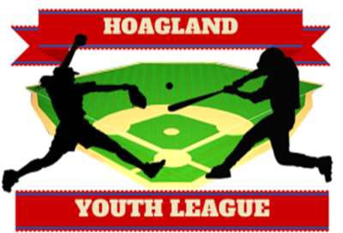Hoagland Youth League

# Register until February 23th at

[***WWW.HOAGLANDBASEBALL.COM***](http://WWW.HOAGLANDBASEBALL.COM/)

# Late registrations will only be accepted if divisions aren’t full, and there will be a $20 late fee. Don’t wait!!!

Returning for 2025: Peewee ages 3&4!

|  |  |  |  |  |  |  |
| --- | --- | --- | --- | --- | --- | --- |
| Peewee | T-Ball | 8U | Minors | Majors | Koufax | Family Maximum |
| $50  Age 3-4 | $65  Age 5-6 | $85  Age 6-8 | $90  Age 9-10 | $95  Age 11-12 | $110  Age 13-14 | $200 |

A one-time $30 Concession & Park User Fee will be paid at time of registration. Limit one fee per family.

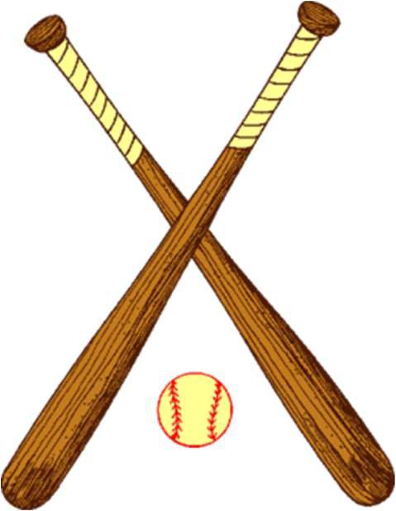

* **Player evaluations at St. Joe Hessen Cassel Gym: Sat. March 8th**

Koufax: 9:00am Girls Major: 1:00pm Boys Major: 9:45am Girls Minor: 1:30pm Boys Minor: 10:30am Girls 8U: 2:00pm Boys 8U: 11:15am Girls 14U: 2:30pm

(Subject to change)

* **Coaches Meeting at the Hoagland Pavilion: Tuesday March 18th 7pm**
* **Practices begin the week of March 24th**
* **Park clean-up days: Saturday April 12th and Saturday April 19th (if necessary).**
* **Picture Day at the Hoagland Pavilion: Saturday April 26th – Times TBD**
* **Games will begin the week of April 28th**. We’ll hold Family and Friends Day activities (player announcement, bounce houses, special food offerings, music, etc.) on Saturday, May 10th.
* **End of Regular Season Tournament the week of June 9th or June 16th.** All divisions except T-Ball. Tourney may spill into the following week depending on rainouts.

Contact Caleb Conrad 260-267-2231, Christy Melcher 260-246-7369, or email hoaglandball@gmail.com if you have any questions.



**Don’t forget to “Like” us on Facebook at *Hoagland Youth League* to stay current on all key dates.**

**If you have any new or gently used baseball & softball equipment/clothing you would like to donate, please bring those items to evaluations on the 8th. All items donated will be used for teams & kids in HYL.**